
SJTC Invitational
Elementary & Middle School Cross Country Meet

Tuesday, October 7th, 2026- 3:30 – 6:00 pm
Organized by the Saint John Track Club & UNBSJ Cross Country/Track Team

Location: Wolastog Park, Lancaster Avenue, West Saint John

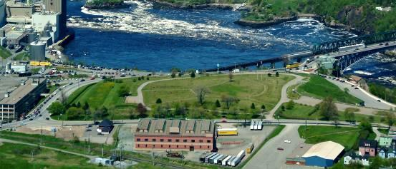
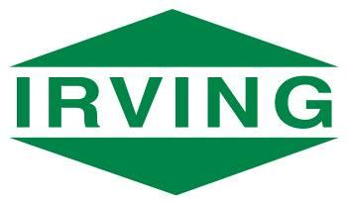
Course Description:
All events will take place on a well-marked course around the perimeter of the park on a mix of grass and trail. The course is a loop of just over 1 km, providing a fast, challenging and exciting race to watch. We want to say a special thank you to sponsor J.D. Irving Limited, for use of the park.

Registration Information:
There is no registration fee and no advance registration required. Questions prior to the event can be sent to saintjohntrack@gmail.com . Individual and team entries are welcome. Registration will occur on site 3:30-4:00 pm. Athletes can walk the course up until 3:45 pm. Please note that teams must have a designated adult in charge of checking-in and recording. All athletes from a school are considered a team with the top 4 finishers to count for scoring. All athletes on a team must attend the same school.

Cancellation: In the event of VERY Severe Weather the event will be cancelled with no rain date. Notification will be provided to the schools as of 11:00 am of the meet day and posted on the SJ Track Club web site at www.SJTC.ca .

Parking: Limited parking is available in the park but overflow is available at various places nearby.

Events: Official course walk-through will take place at 3:30.
Races will start promptly at 4:00 and occur in the order shown below.
Division Distance
Grade 3 - Girls 1.1 km
Grade 3 - Boys 1.1 km
Grade 4 - Girls 1.1 km
Grade 4 - Boys 1.1 km
Grade 5 - Girls 1.1 km
Grade 5 - Boys 1.1 km
Grade 6 Boys & Girls 1 x 1.1 km loop
Grade 7 Boys & Girls 1 x 1.1 km loop
Grade 8 Boys & Girls 2 x 1.1 km loop
Awards: Participant ribbons for all competitors. Medals for the top 6 individual and ribbons for the top 6 teams.
For More Information: Oy Akinola at 204-998-0743, Bill MacMackin at 506-647-4931

The park entrance is across from the Bowlarama, 248 Lancaster Ave.
Please avoid parking in the bowlarama parking area.

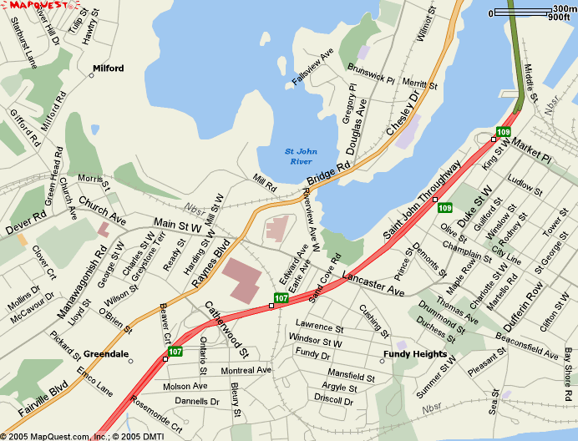

Race Course
